**CS4110 HW #5**

**Chapter 8:**

**4.**

i**.** 1000000

**ii.** 000111

**iii**. 111010

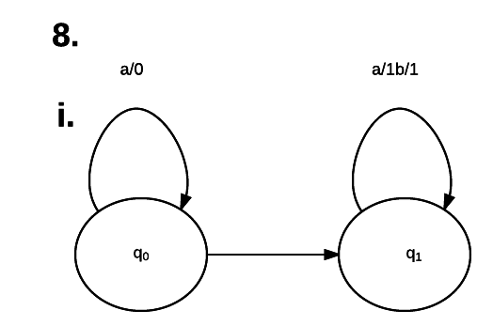

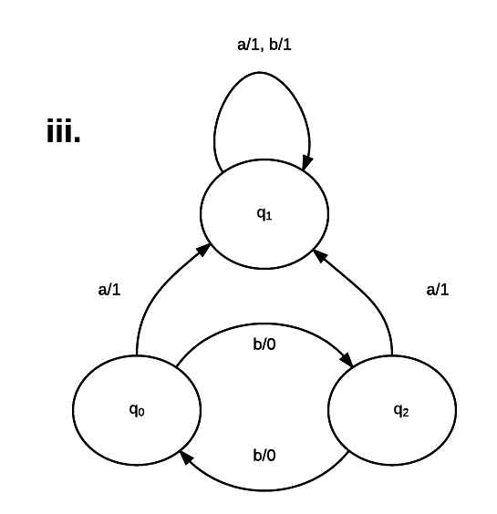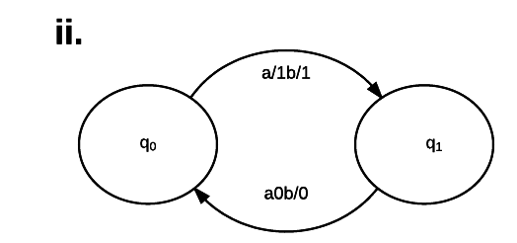

b/1

**Chapter 9 - #1:**

**L1**: All words that end in a

**L2**: All words starting with b

**R1**: (a+b)*a

**R2**: b(a+b)*

**Regex**: b(a+b)*a

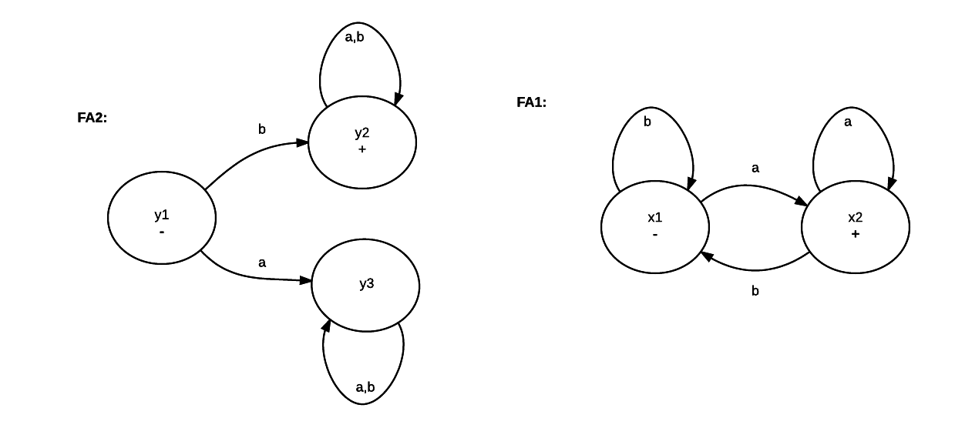

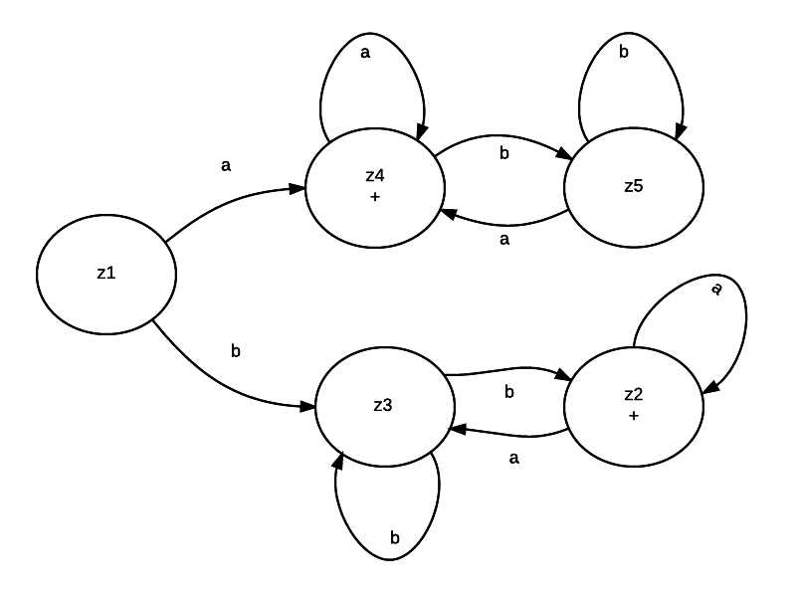

Intersection L1/L2

|  |  |
| --- | --- |
| - z1 | x1 + y1 |
| + z2 | x2 + y2 |
| z3 | x1 + y2 |
| z4 | x2 + y3 |
| z5 | x1 + y3 |